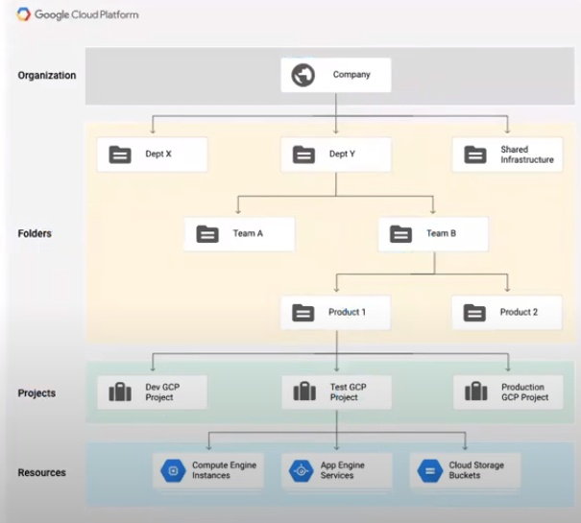

Vpc is global
Routing will be also global

Regional resources
Subnet
zonal
virtual machine
Vpc is global
Routing will be also global
Regional resources
subnet
zonal
virtual machine

Project is the fundamental organizing entity
GCP resources must belong to a project
made up of the settings, permissions, and other metadata that describe applications
contains the computing, storage and networking resources

* A project can't access another project's resources unless you use
1- shared VPC or
2- VPC network peering

Basic GCP Networking Components
* GCP Regions and zones
* VPC/Subnets
* VPC peering
* Implicit Routing (in shared vpc, Subnet can communicate, GCP is doing it for you)
* VPN

For connect to outside world you connect by VPN gateway.(ON-premise)
If you have public IP in you vm you can go out-side by
IGW (internet gateway).

Global routing:
* VPC is global resource
* All the subnets, irrespective of region are inherently routable with a VPC.
* subnets/CIDR are Regional resource
* Projects can contain multiple "VPC networks"

VPC Network and subnets
* "VPC networks" consist of one or more subnets
* "VPC networks" don't have any IP address ranges associated with the (IP ranges are defined at subnet level)
* VPC subnets can be created in
* auto mode( creates subnets in each region automatically)
* Custom mode( VPC network start with no subnets)
* You can create more than one subnet per region.

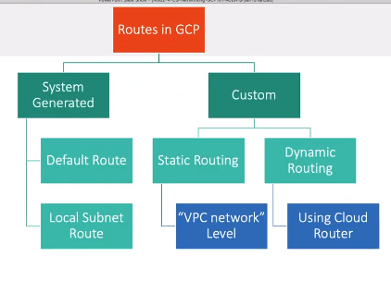

Custom Dynamic Route
Using cloud router
* cloud router (CR) is for dynamic routing
* At the time of VPC network creation, you setup mode for CR.
* The mode for CR depends on the "VPC network" Dynamci routing mode.
Regional
CR will learn routes only in the region in which they were created.
Global:
CR will learn routes to and from all regions with a single VPN or interconnect.
Transit(inter-VPC) Networking
(This is where everything will connect)
* Lacks native Transit solution to interconnect VPCs.
* VPC peering preferred
* Preaching single VPC

VPC Peering
* Same qualities as from other cloud service provider.
* All pre-programmed routes from the two VPCs are announced to each other.
* Used to connect multiple VPCs
* Non-transitive

cloud interconnect.
* connect your on-prem network to your vpc network through a private connection. (that you by from third party venders)
* Limitation: Not encrypted

1. Dedicated interconnect:
* 10 Gbps or 100 Gbps pipes
* connect directly to GCP
2- Partner interconnect:
* 50 Mbps to 10 Gbps
Dedicated interconnect:
* Dedicated interconnect enables you to connect your existing network to your vpc network through a highly available, low-latency, enterprise-grade connection.
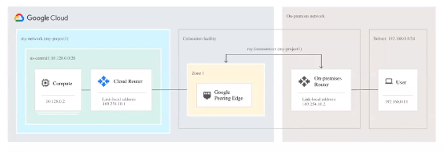

Why GCP cloud
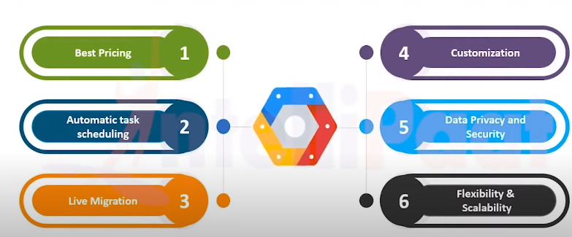

Google is offering these services
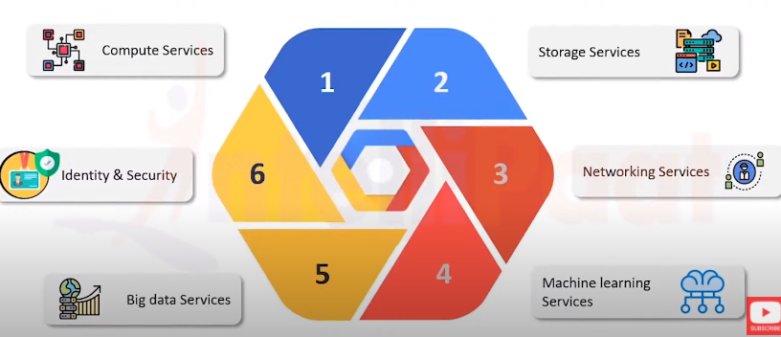

Cloud storage :
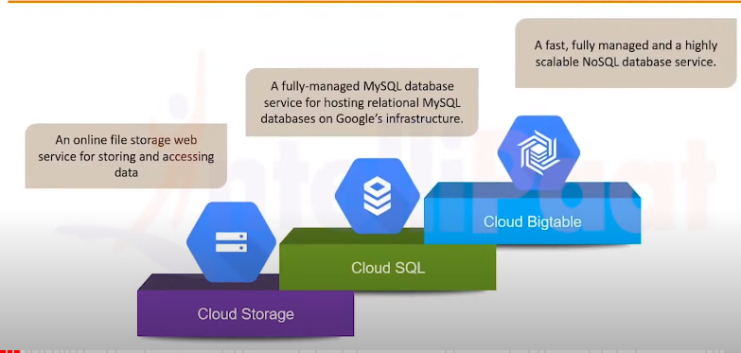

Loadbalancer
* Classic - If you want your traffic should be distributed equally in your server then use classic loadbalancer.
* Application- If you want distributes traffic on the bases of request you are getting on your application then use application loadbalancer.

Networking component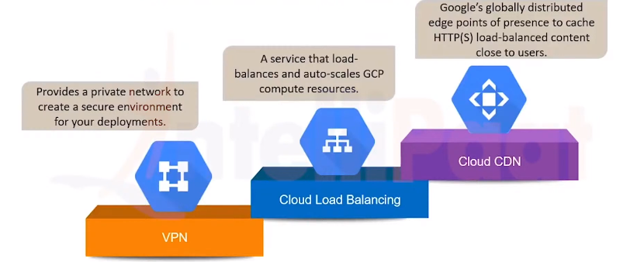
Identity & security services
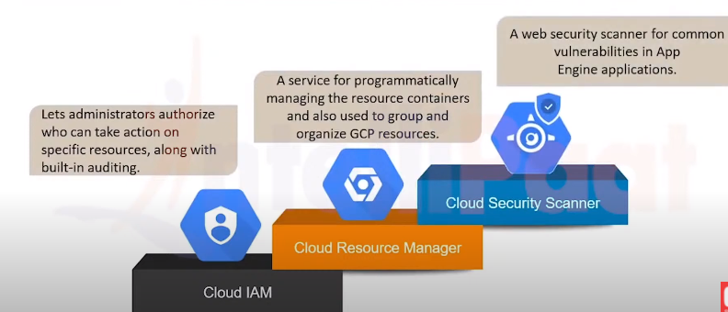

GCP security
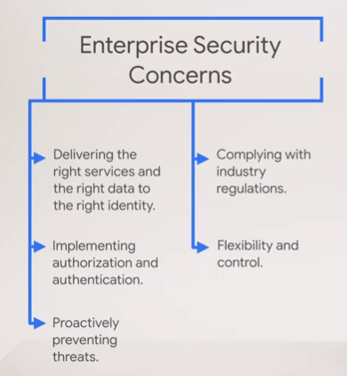

Responsibility
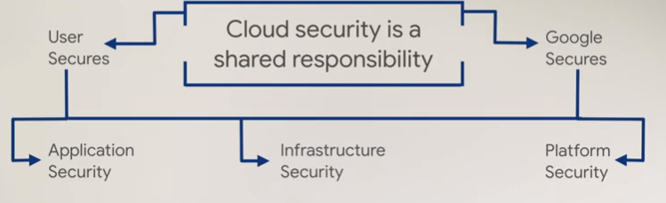
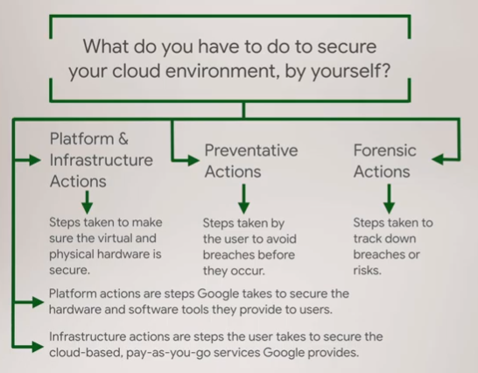

What tools google is providing
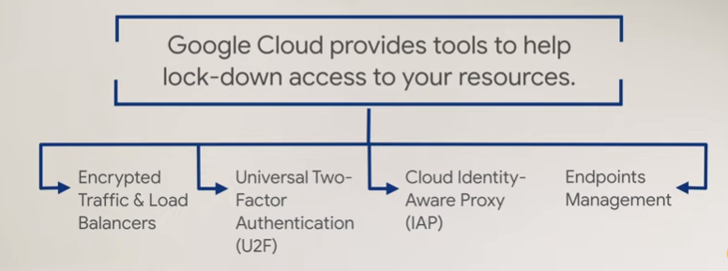
How it is work – Loadbalaner send traffic to ddos server
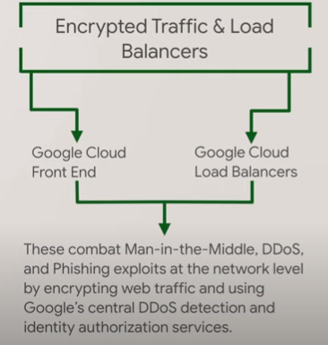
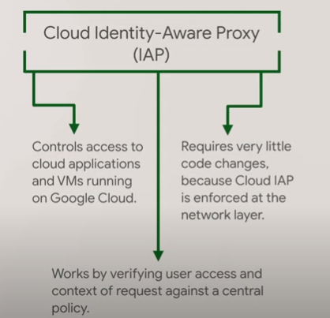
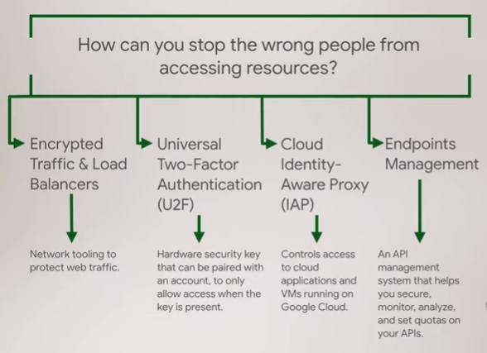

For data safe:
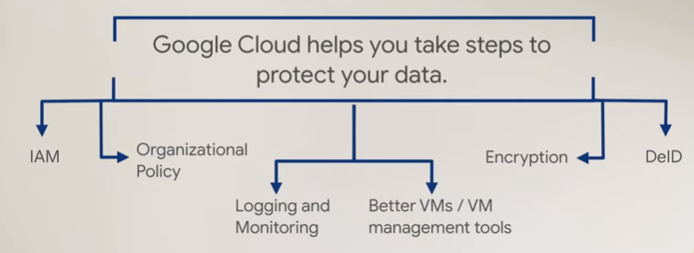
What IAM do
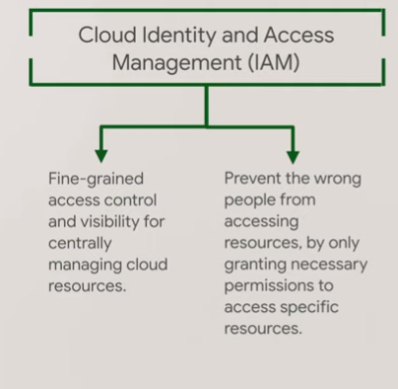

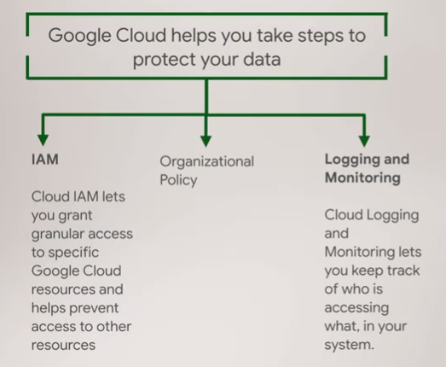
Vm logging and monitoring
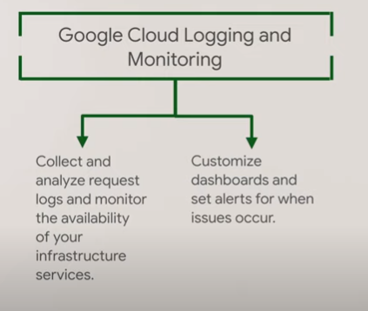
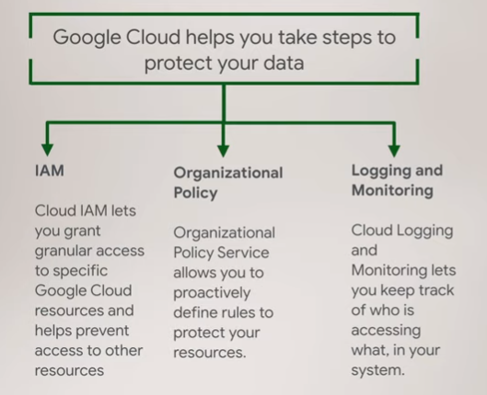
Organizational Policy
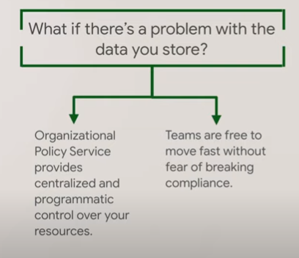
You can setup like new created instance and sql instance and restart any sql instance you need custom manage encrypting key.
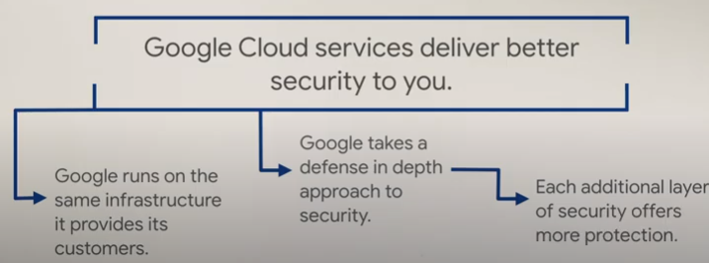

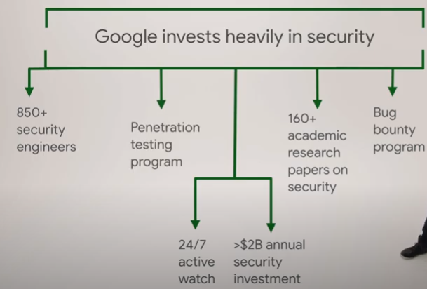
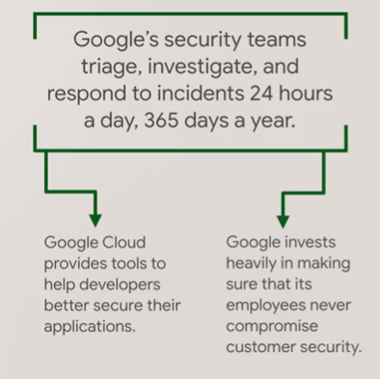
Network
